Spectral star type: O

Color: Blue

Approximate surface temperature: over 25 000 K

Average mass to comparison with Sun (Sun mass = 1): 60

Average radius to comparison with Sun (Sun radius = 1): 15

Average luminosity to comparison with Sun (Sun luminosity = 1): 1 400 000

Main characteristic:

An O-type star is a hot, blue-white [star](https://en.wikipedia.org/wiki/Star) of [spectral type](https://en.wikipedia.org/wiki/Spectral_type) [O](https://en.wikipedia.org/wiki/Stellar_classification#Class_O) in the [Yerkes classification system](https://en.wikipedia.org/wiki/Stellar_classification#Yerkes_spectral_classification) employed by [astronomers](https://en.wikipedia.org/wiki/Astronomers). They have temperatures in excess of 30,000 [kelvin](https://en.wikipedia.org/wiki/Kelvin) (K). Stars of this type have strong [absorption lines](https://en.wikipedia.org/wiki/Spectral_line) of ionised helium, strong lines of other ionised elements, and hydrogen and neutral helium lines weaker than [spectral type B](https://en.wikipedia.org/wiki/B-type_star#Class_B).

Stars of this type are very rare, but because they are very bright they can be seen at great distances and four of the 90 [brightest stars as seen from Earth](https://en.wikipedia.org/wiki/List_of_brightest_stars) are O type. Due to their high mass, O-type stars end their lives rather quickly in violent [supernova](https://en.wikipedia.org/wiki/Supernova) explosions, resulting in [black holes](https://en.wikipedia.org/wiki/Black_hole) or [neutron stars](https://en.wikipedia.org/wiki/Neutron_star). Most of these stars are young massive [main sequence](https://en.wikipedia.org/wiki/Main_sequence), giant, or supergiant stars, but the central stars of [planetary nebulae](https://en.wikipedia.org/wiki/Planetary_nebula), old low-mass stars near the end of their lives, also usually have O spectra.

O-type stars are typically located in regions of active [star formation](https://en.wikipedia.org/wiki/Star_formation), such as the [spiral arms](https://en.wikipedia.org/wiki/Spiral_arm) of a [spiral galaxy](https://en.wikipedia.org/wiki/Spiral_galaxy) or a pair of galaxies undergoing collision and merger (such as the [Antennae Galaxies](https://en.wikipedia.org/wiki/Antennae_Galaxies)). These stars illuminate any surrounding material and are largely responsible for the distinct coloration of a galaxy's arms. Furthermore, O-type stars often occur in [multiple star](https://en.wikipedia.org/wiki/Multiple_star) systems, where their evolution is more difficult to predict due to mass transfer and the possibility of component stars exploding as supernovae at different times.

Examples:

* HD 93129
* 10 Lacertra
* [Pismis 24-17](https://en.wikipedia.org/wiki/Pismis_24)

Pictures:

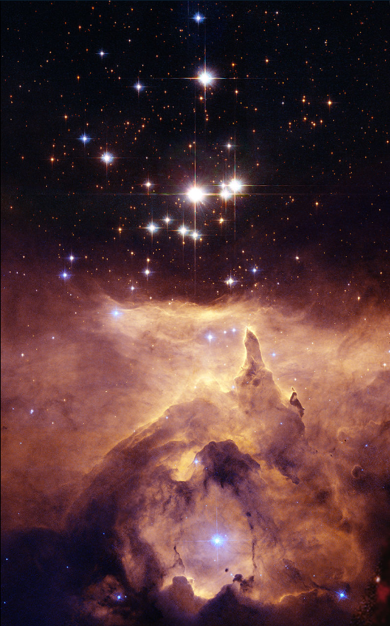

Figure : Pismis 24-17

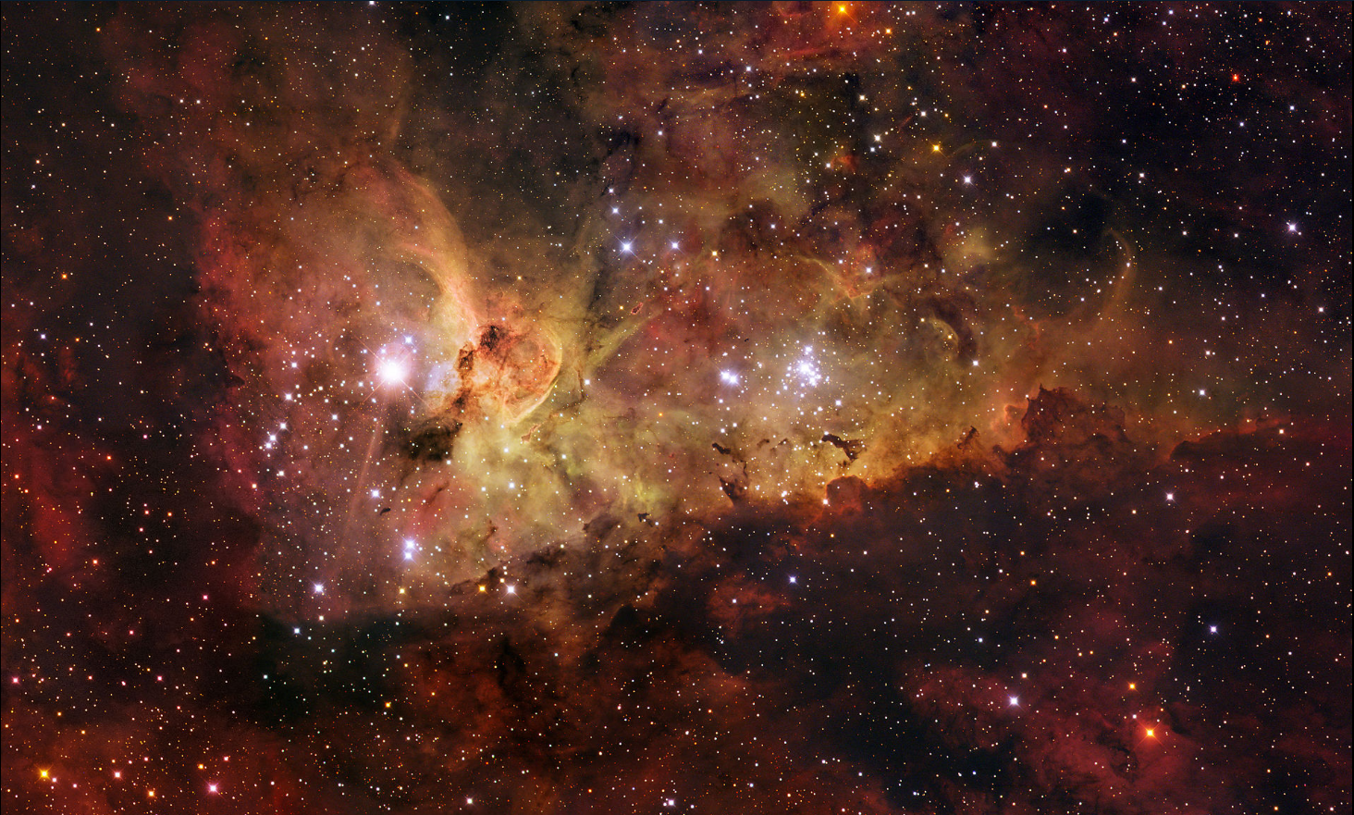

Figure : HD 93129

Spectral star type: B

Color: Blue

Approximate surface temperature: 11 000 K - 25 000 K

Average mass to comparison with Sun (Sun mass = 1): 18

Average radius to comparison with Sun (Sun radius = 1): 7

Average luminosity to comparison with Sun (Sun luminosity = 1): 20 000

Main characteristic:

A B-type main-sequence star (B V) is a [main-sequence](https://en.wikipedia.org/wiki/Main_sequence) ([hydrogen](https://en.wikipedia.org/wiki/Hydrogen" \o "Hydrogen)-burning) [star](https://en.wikipedia.org/wiki/Star) of [spectral type B](https://en.wikipedia.org/wiki/Stellar_classification#Type_B) and luminosity class V. These stars have from 2 to 16 times the [mass](https://en.wikipedia.org/wiki/Solar_mass) of the [Sun](https://en.wikipedia.org/wiki/Sun) and [surface temperatures](https://en.wikipedia.org/wiki/Effective_temperature) between 10,000 and 30,000 [K](https://en.wikipedia.org/wiki/Kelvin).[[2]](https://en.wikipedia.org/wiki/B-type_main-sequence_star#cite_note-2) B-type stars are extremely luminous and blue. Their spectra have neutral [helium](https://en.wikipedia.org/wiki/Helium), which are most prominent at the B2 subclass, and moderate hydrogen lines. Examples include [Regulus](https://en.wikipedia.org/wiki/Regulus) and [Algol A](https://en.wikipedia.org/wiki/Algol_A).

This class of stars was introduced with the Harvard sequence of stellar spectra and published in the [*Revised Harvard photometry* catalogue](https://en.wikipedia.org/wiki/Harvard_Revised_Photometry_Catalogue). The definition of type B-type stars was the presence of non-[ionized](https://en.wikipedia.org/wiki/Ionized) helium lines with the absence of singly ionized helium in the blue-violet portion of the spectrum. All of the spectral classes, including the B type, were subdivided with a numerical suffix that indicated the degree to which they approached the next classification. Thus B2 is 1/5 of the way from type B (or B0) to [type A](https://en.wikipedia.org/wiki/A-type_main-sequence_star).

Type-B stars don't have a [corona](https://en.wikipedia.org/wiki/Stellar_corona) and lack a [convection zone](https://en.wikipedia.org/wiki/Convection_zone) in their outer atmosphere. They have a higher mass loss rate than smaller stars such as the Sun, and their stellar wind has velocities of about 3,000 km/s. The energy generation in main-sequence B-type stars comes from the [CNO cycle](https://en.wikipedia.org/wiki/CNO_cycle) of [thermonuclear fusion](https://en.wikipedia.org/wiki/Thermonuclear_fusion). Because the CNO cycle is very temperature sensitive, the energy generation is heavily concentrated at the center of the star, which results in a convection zone about the core. This results in a steady mixing of the hydrogen fuel with the helium byproduct of the nuclear fusion. Many B-type stars have a rapid rate of [rotation](https://en.wikipedia.org/wiki/Stellar_rotation), with an equatorial rotation velocity of about 200 km/s.

Examples:

* HIP 78530 b
* Spica
* Kappa Andromedae b

Pictures:

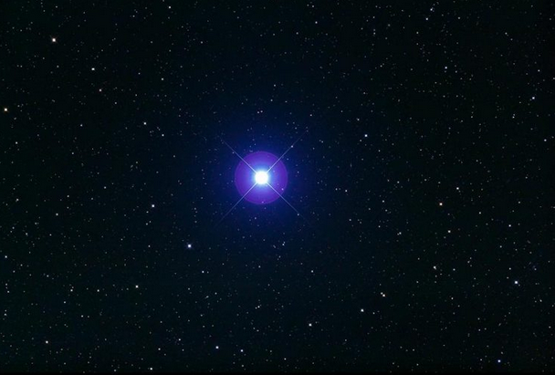

Figure : Spica

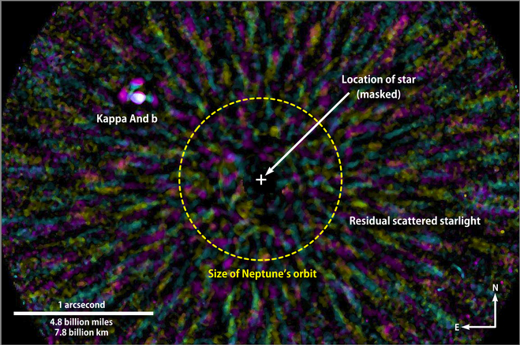

Figure : Kappa Andromedae b

Spectral star type: A

Color: Blue

Approximate surface temperature: 7 500 K - 11 000 K

Average mass to comparison with Sun (Sun mass = 1): 3,2

Average radius to comparison with Sun (Sun radius = 1): 2,5

Average luminosity to comparison with Sun (Sun luminosity = 1): 80

Main characteristic:

An A-type main-sequence star (A V) or A dwarf star is a [main-sequence](https://en.wikipedia.org/wiki/Main_sequence) ([hydrogen](https://en.wikipedia.org/wiki/Hydrogen" \o "Hydrogen)-burning) [star](https://en.wikipedia.org/wiki/Star) of [spectral type](https://en.wikipedia.org/wiki/Stellar_classification) A and [luminosity class](https://en.wikipedia.org/wiki/Luminosity_class) V. These stars have [spectra](https://en.wikipedia.org/wiki/Electromagnetic_spectrum) which are defined by strong [hydrogen Balmer absorption lines](https://en.wikipedia.org/wiki/Balmer_series). They have [masses](https://en.wikipedia.org/wiki/Mass) from 1.4 to 2.1 times the [mass](https://en.wikipedia.org/wiki/Solar_mass) of the [Sun](https://en.wikipedia.org/wiki/Sun) and [surface temperatures](https://en.wikipedia.org/wiki/Effective_temperature) between 7600 and 10,000  [K](https://en.wikipedia.org/wiki/Kelvin). Bright and nearby examples are [Altair](https://en.wikipedia.org/wiki/Altair) (A7 V), [Sirius A](https://en.wikipedia.org/wiki/Sirius_A) (A1 V), and [Vega](https://en.wikipedia.org/wiki/Vega) (A0 V). A-type stars don't have a [convective zone](https://en.wikipedia.org/wiki/Convective_zone) and thus aren't expected to harbor a [magnetic dynamo](https://en.wikipedia.org/wiki/Stellar_magnetic_field). As a consequence, because they don't have strong [stellar winds](https://en.wikipedia.org/wiki/Stellar_wind) they lack a means to generate [X-ray emission](https://en.wikipedia.org/wiki/X-ray_astronomy).

In July 2019, astronomers reported finding an A-type star, [S5-HVS1](https://en.wikipedia.org/wiki/S5-HVS1), traveling 1,755 km/s (3,930,000 mph), faster that any other star detected so far. The star is in the [Grus](https://en.wikipedia.org/wiki/Grus_(constellation)) (or Crane) [constellation](https://en.wikipedia.org/wiki/Constellation) in the southern sky, and about 29,000 light-years from Earth, and may have been ejected out of the [Milky Way](https://en.wikipedia.org/wiki/Milky_Way) [galaxy](https://en.wikipedia.org/wiki/Galaxy) after interacting with [Sagittarius A*](https://en.wikipedia.org/wiki/Sagittarius_A*), the [supermassive black hole](https://en.wikipedia.org/wiki/Supermassive_black_hole) at the center of the galaxy.

Examples:

* Altair
* Vega
* Sirius

Pictures:

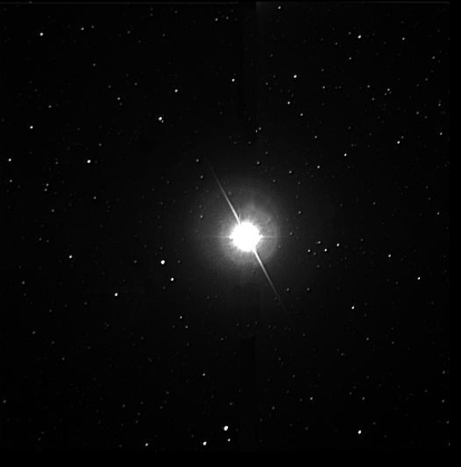

Figure : Altair

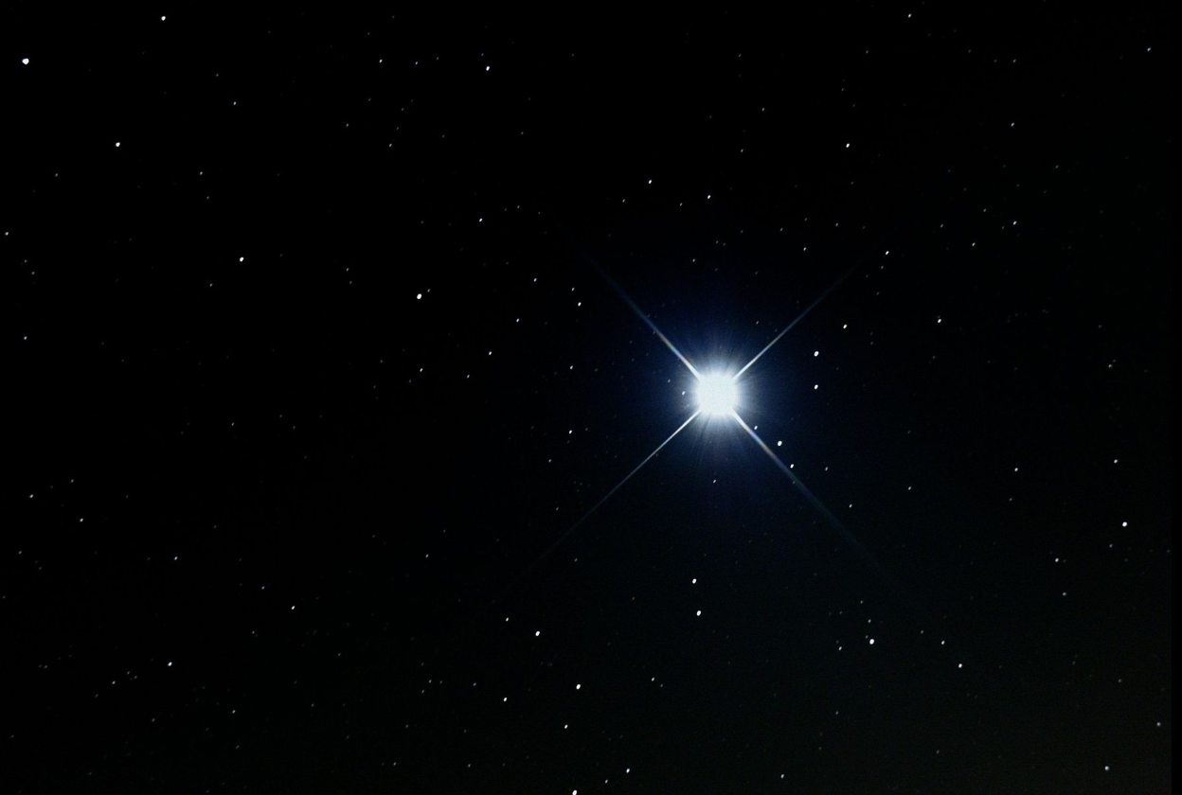

Figure : Sirius

Spectral star type: F

Color: Blue to White

Approximate surface temperature: 6 000 K - 7 500 K

Average mass to comparison with Sun (Sun mass = 1): 1,35

Average radius to comparison with Sun (Sun radius = 1): 1,3

Average luminosity to comparison with Sun (Sun luminosity = 1): 6

Main characteristic:

An F-type main-sequence star (F V) is a [main-sequence](https://en.wikipedia.org/wiki/Main_sequence), [hydrogen](https://en.wikipedia.org/wiki/Hydrogen)-fusing [compact star](https://en.wikipedia.org/wiki/Compact_star) of [spectral type](https://en.wikipedia.org/wiki/Spectral_classification) F and luminosity class V. These stars have from 1.0 to 1.4 times the [mass](https://en.wikipedia.org/wiki/Solar_mass) of the [Sun](https://en.wikipedia.org/wiki/Sun) and [surface temperatures](https://en.wikipedia.org/wiki/Effective_temperature) between 6,000 and 7,500 [K](https://en.wikipedia.org/wiki/Kelvin). This temperature range gives the F-type stars a yellow-white hue. Because a main-sequence star is referred to as a dwarf star, this class of star may also be termed a yellow-white dwarf (not to be confused with cooler [white dwarfs](https://en.wikipedia.org/wiki/White_dwarf)).

Examples:

* [Procyon A](https://en.wikipedia.org/wiki/Procyon_A)
* [Gamma Virginis](https://en.wikipedia.org/wiki/Gamma_Virginis)
* [KIC 8462852](https://en.wikipedia.org/wiki/KIC_8462852)

Pictures:

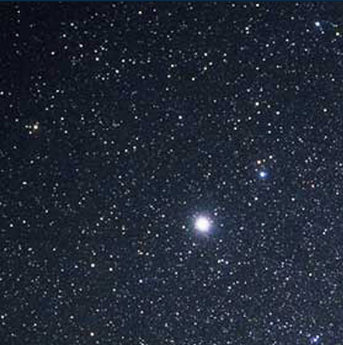

Figure : Procyon A

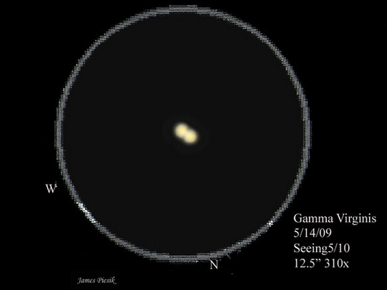

Figure : Gamma Virginis

Spectral star type: G

Color: White to Yellow

Approximate surface temperature: 5 000 K - 6 000 K

Average mass to comparison with Sun (Sun mass = 1): 1,1

Average radius to comparison with Sun (Sun radius = 1): 1,1

Average luminosity to comparison with Sun (Sun luminosity = 1): 1,2

Main characteristic:

A G-type main-sequence star (Spectral type: G-V), often (and imprecisely) called a yellow dwarf, or G dwarf star, is a [main-sequence](https://en.wikipedia.org/wiki/Main_sequence) [star](https://en.wikipedia.org/wiki/Star) (luminosity class V) of [spectral type](https://en.wikipedia.org/wiki/Stellar_classification) G. Such a star has about 0.84 to 1.15 [solar masses](https://en.wikipedia.org/wiki/Solar_mass) and [surface temperature](https://en.wikipedia.org/wiki/Effective_temperature) of between 5,300 and 6,000 [K](https://en.wikipedia.org/wiki/Kelvin). Like other main-sequence stars, a G-type main-sequence star is converting the [element](https://en.wikipedia.org/wiki/Chemical_element) [hydrogen](https://en.wikipedia.org/wiki/Hydrogen) to [helium](https://en.wikipedia.org/wiki/Helium) in its core by means of [nuclear fusion](https://en.wikipedia.org/wiki/Nuclear_fusion). The [Sun](https://en.wikipedia.org/wiki/Sun), the star to which the Earth is gravitationally bound in the [Solar System](https://en.wikipedia.org/wiki/Solar_System) and the object with the largest [apparent magnitude](https://en.wikipedia.org/wiki/Apparent_magnitude), is an example of a G-type main-sequence star (G2V type). Each second, the Sun fuses approximately 600 million [tons](https://en.wikipedia.org/wiki/Ton) of hydrogen to helium, [converting](https://en.wikipedia.org/wiki/Mass%E2%80%93energy_equivalence) about 4 million tons of [matter](https://en.wikipedia.org/wiki/Matter) to [energy](https://en.wikipedia.org/wiki/Energy).

Examples:

* [Alpha Centauri A](https://en.wikipedia.org/wiki/Alpha_Centauri_A)
* [Tau Ceti](https://en.wikipedia.org/wiki/Tau_Ceti)
* [51 Pegasi](https://en.wikipedia.org/wiki/51_Pegasi)

Pictures:

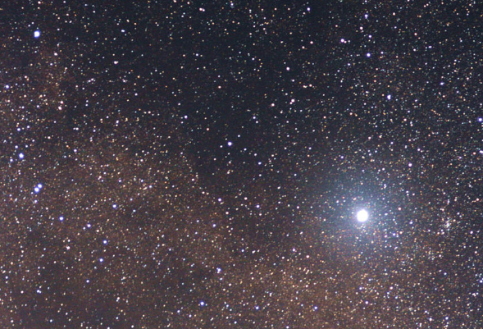

Figure : Alpha Centauri A

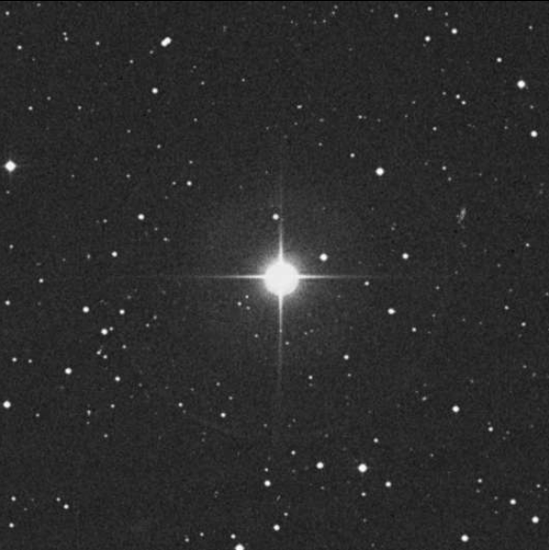

Figure : 51 Pegasi

Spectral star type: K

Color: Orange to Red

Approximate surface temperature: 3 500 K - 5 000 K

Average mass to comparison with Sun (Sun mass = 1): 0,8

Average radius to comparison with Sun (Sun radius = 1): 0,9

Average luminosity to comparison with Sun (Sun luminosity = 1): 0,4

Main characteristic:

A K-type main-sequence star, also referred to as a K dwarf or Orange dwarf, is a [main-sequence](https://en.wikipedia.org/wiki/Main_sequence) ([hydrogen](https://en.wikipedia.org/wiki/Hydrogen" \o "Hydrogen)-burning) [star](https://en.wikipedia.org/wiki/Star) of [spectral type](https://en.wikipedia.org/wiki/Spectral_classification) K and [luminosity class](https://en.wikipedia.org/wiki/Luminosity_class) V. These stars are intermediate in size between red [M-type main-sequence stars](https://en.wikipedia.org/wiki/Red_dwarf) ("red dwarfs") and yellow [G-type main-sequence stars](https://en.wikipedia.org/wiki/G-type_main-sequence_star). They have masses between 0.5 and 0.8 times the [mass](https://en.wikipedia.org/wiki/Solar_mass) of the [Sun](https://en.wikipedia.org/wiki/Sun)and [surface temperatures](https://en.wikipedia.org/wiki/Effective_temperature) between 3,900 and 5,200 [K](https://en.wikipedia.org/wiki/Kelvin). These stars are of particular interest in the search for [extraterrestrial life](https://en.wikipedia.org/wiki/Extraterrestrial_life).

Examples:

* [Alpha Centauri B](https://en.wikipedia.org/wiki/Alpha_Centauri_B)
* [Epsilon Indi](https://en.wikipedia.org/wiki/Epsilon_Indi)
* Arcturus

Pictures:

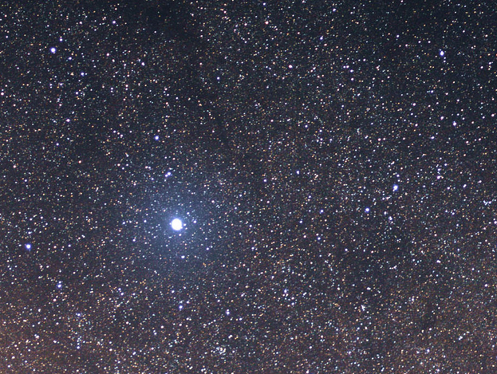

Figure : Alpha Centauri B

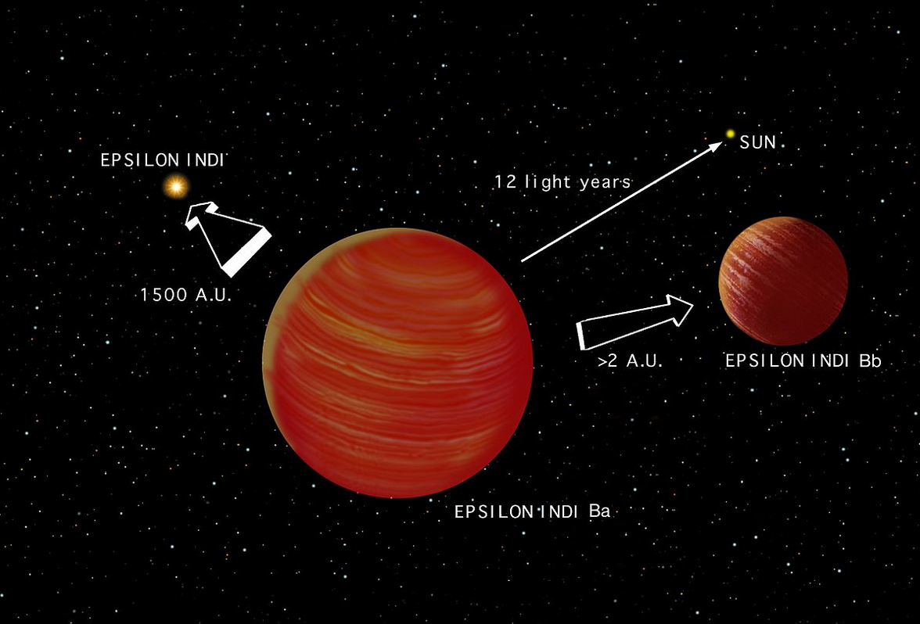

Figure : Epsilon Indi

Spectral star type: M

Color: Red

Approximate surface temperature: under 3 500 K

Average mass to comparison with Sun (Sun mass = 1): 0,3

Average radius to comparison with Sun (Sun radius = 1): 0,4

Average luminosity to comparison with Sun (Sun luminosity = 1): 0,04

Main characteristic:

A red dwarf is the smallest and coolest kind of [star](https://en.wikipedia.org/wiki/Star) on the [main sequence](https://en.wikipedia.org/wiki/Main_sequence). Red dwarfs are by far the most common type of star in the [Milky Way](https://en.wikipedia.org/wiki/Milky_Way), at least in the neighborhood of the [Sun](https://en.wikipedia.org/wiki/Sun), but because of their low luminosity, individual red dwarfs cannot be easily observed. From Earth, not one that fits the stricter definitions of a red dwarf is visible to the naked eye.[[1]](https://en.wikipedia.org/wiki/Red_dwarf#cite_note-1) [Proxima Centauri](https://en.wikipedia.org/wiki/Proxima_Centauri), the nearest star to the Sun, is a red dwarf, as are fifty of the [sixty nearest stars](https://en.wikipedia.org/wiki/List_of_nearest_stars). According to some estimates, red dwarfs make up three-quarters of the stars in the Milky Way.

The coolest red dwarfs near the Sun have a surface temperature of ~2,000 [K](https://en.wikipedia.org/wiki/Kelvin) and the smallest have radii of ~9% that of the Sun, with masses about ~7.5% that of the Sun. These red dwarfs have spectral classes of L0 to L2. There is some overlap with the properties of brown dwarfs, since the most massive brown dwarfs at lower metallicity can be as hot as 3,600 K and have late M spectral types.

Examples:

* [Beta Andromedae](https://en.wikipedia.org/wiki/Beta_Andromedae)
* [Chi Pegasi](https://en.wikipedia.org/wiki/Chi_Pegasi)
* [Betelgeuse](https://en.wikipedia.org/wiki/Betelgeuse)

Pictures:

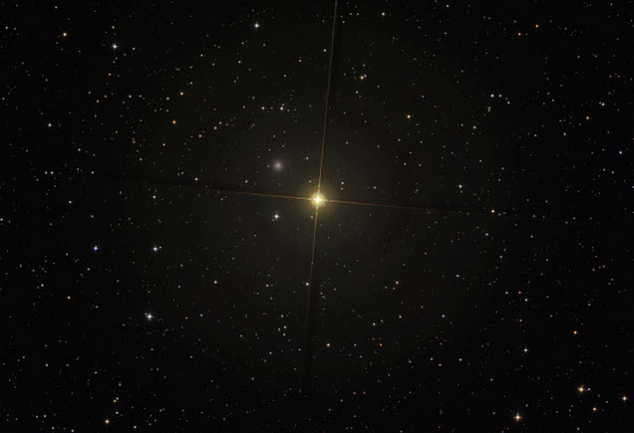

Figure : Beta Andromedae

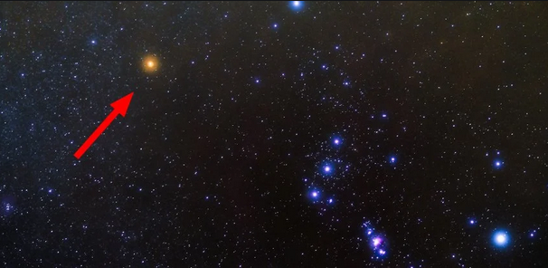

Figure : Betelgeuse